**Project Identification**

|  |  |
| --- | --- |
| **Project:** | T28 – Goodie Foodie App |
| **Prepared By:** | Loman Chan Shum, Elam He, Hui Qiu, Hsin Yu Ivy Tsai, Alex Tsang |
| **Document Version:** | 1.0.0 |
| **Published Date:** | Sep 25, 2022 |

**Contributors**

|  |  |
| --- | --- |
| **Name** | **Title** |
| Loman Chan Shum | Project Leader (Acting) |
| Elam He | Member |
| Hsin Yu Ivy Tsai | Member |
| Hui Qiu | Member |
| Alex Tsang | Business Analyst |

**Distribution**

*This document is distributed to all the following people.*

|  |  |
| --- | --- |
| **Name** | **Title** |
| Loman Chan Shum | Project Leader (Acting) |
| Elam He | Member |
| Hsin Yu Ivy Tsai | Member |
| Hui Qiu | Member |
| Alex Tsang | Business Analyst |

**Referenced Documents**

|  |  |  |  |  |
| --- | --- | --- | --- | --- |
| **Version number** | **Title** | **Author** | **Date** | **Source / Location** |
| 1.0 | **49+ Mobile App Ideas That Haven't Been Made (2022 Update)** | Felgo | *Jan 4, 2022* | <https://blog.felgo.com/cross-platform-app-development/mobile-app-ideas> |
| *1.0* | A Guide To Develop A Cooking Recipe | Harnil Oza |  | <https://www.hyperlinkinfosystem.com/blog/a-guide-to-develop-a-cooking-recipe-app-key-features-cost-estimates> |
|  |  |  |  |  |

**Revision History**

|  |  |  |  |
| --- | --- | --- | --- |
| **Version Number** | **Revision Date** | **Summary of Changes** | **Modified by** |
| 0.9 | 9/30/2022 | First High-Level Requirement Document | Loman Chan Shum, Elam He, Hui Qiu, Hsin Yu Ivy Tsai, Alex Tsang |

**TABLE OF CONTENTS**

***1.*** ***Business Context Diagram*** ***3***

***2.*** ***Requirements Scope Statements***  ***4***

***3.*** ***High Level Business Requirements (HLR) Traceability*** ***4***

***4.*** ***High Level Business Requirements Sign-Off*** ***5***

1. **Business Context Diagram**

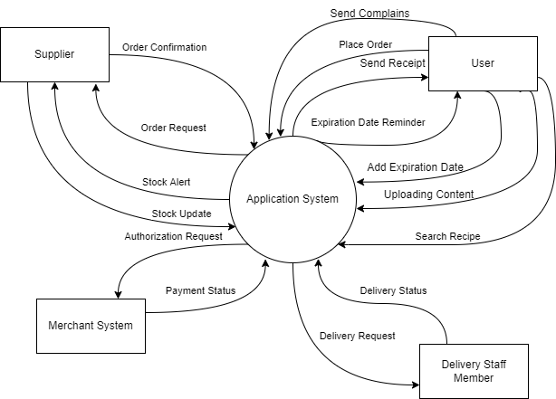

|  |  |
| --- | --- |
| **Requirement Scope Area** | **Description** |
| Application System | Area responsible for users to search recipes, post contents, track ingredients’ expiration dates, shop grocery online and updating inventory. |

|  |  |
| --- | --- |
| **External Entity** | **Description** |
| Delivery Staff Member | A person who delivers the goods ordered by Users. |
| Suppliers | Also known as grocery store that provides ingredients and delivery service to another entity. |
| User | Who utilizes all kinds of services in the app. |
| Merchant System (eService) | Essentially used to accept and process payment from customers, often handing electronic payment of credit card processing. |

|  |  |
| --- | --- |
| **Information Flows** | **Description** |
| Search Recipe | Generate recipe for users with a URL |
| Authorization Request | Request for transaction. |
| Payment Status | Payment is approved or denied. |
| Order Request | Order is sent to Supplier. |
| Confirm Order | Order is confirmed. |
| Stock Alert | Send an alert to supplier when item in stock is low. |
| Stock Update | Suppliers update their inventory. |
| Expiration Date Reminder | Notify users when an item is about to expire or is expired. |
| Adding Expiration Date | Users can input the expiry date of an ingredient. |
| Uploading Content | Users are uploading a post or other content. |
| Send Complaint | System receive it and customer service will look at it. |
| Send Receipt | Users receive their receipt. |
| Place Order | Users place an order from an online grocery store. |
| Delivery Request | Delivery staff receive the request. |
| Delivery Status | Update delivery status. |

1. **Requirements Scope Statements**

|  |  |  |
| --- | --- | --- |
| **HLR#** | **Description** | **Priority**  **(H, M, L)** |
| HRL01 | Users must be able to search for recipes | H |
| HRL02 | Users must be able to place online orders | M |
| HRL03 | Users must receive expiration date notification | L |
| HRL04 | Users must be able to post content | H |
| HRL05 | Users must receive a digital receipt after placing an order | H |
| HRL06 | Users must be able to add expiration date | M |
| HRL07 | Delivery Staff must be able to receive delivery requests before carrying out the order | H |
| HRL08 | Suppliers must be able to receive order requests | H |
| HRL09 | Suppliers must be able to receive a low stock alert | H |
| HRL10 | Users should be able to see the delivery status of their order | M |
| HRL11 | Users must be able to send reports on issues | L |

1. **High Level Business Requirements Sign-Off**

# *The undersigned acknowledge their agreement with the contents of Version 1.0.0 of the High-Level Requirements document for Goodie Foodie App*.

*Following approval of this document, requirements changes will be governed by the project’s change management process, including impact analysis and appropriate reviews and approvals, under the general control of the Project Plan and according to company policy. Approved Change Request Documents, if present, will be attached to this Requirements Document as updates.*

|  |  |  |
| --- | --- | --- |
| **Name** | **Project Role and**  **Functional Area** | **Date Signed** |
| Loman Chan Shum |  | Sep 30, 2022 |
| Elam He |  | Sep 30, 2022 |
| Hsin Yu Ivy Tsai |  | Sep 30, 2022 |
| Hui Qiu |  | Sep 30, 2022 |
| Alex Tsang |  | Sep 30, 2022 |